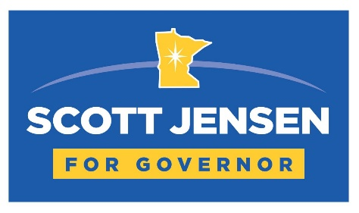

Dear Precinct Caucus Attendee,
Minnesota used to represent a simple promise: work hard, play fair, and you’d have a real shot at a good life. Today, that promise feels broken.
Crime is rising. Too many schools are failing our kids. Small businesses, the backbone of family livelihoods—are being squeezed by taxes and mandates. Everywhere I go, whether it’s a café, a classroom, or a clinic, I hear the same question: What happened to our Minnesota?
I’m not running to manage the mess. I’m running to fix it—for our families and for our future.
This campaign isn’t about politics as usual. It’s about restoring citizen leadership and returning power to the people. Safer streets. Better schools. Real accountability. A government that listens instead of lectures.
Minnesotans don’t want chaos or corruption. They want common-sense leadership that puts families, teachers, law enforcement, farmers, and small business owners back at the table.
Your participation in the precinct caucus matters. This is where our movement begins—neighbors talking with neighbors, citizens stepping out of the stands and into the arena. If you believe it’s time to shake things up and reclaim what makes Minnesota strong, I ask you to stand with us.
Together, we can get Minnesota back on track.
Respectfully,
Scott Jensen
Candidate for Governor of Minnesota
I invite you to watch our campaign launch video and learn more about our vision for Minnesota’s future here…


