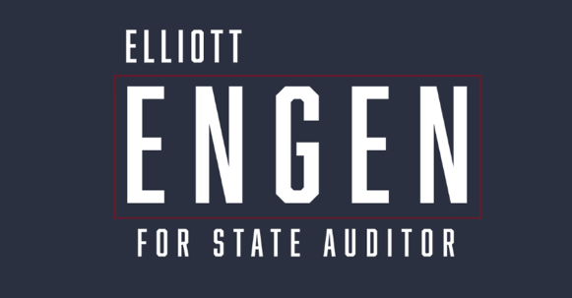

Dear Delegates and Alternates,
My name is Elliott Engen and I’m running for State Auditor. Are you sick of the fraud? Do you wish someone would do something about it? Well, we’re going to use the Office of State Auditor to investigate and expose it. Keep in mind – the State of Minnesota does NOT have constitutional responsibilities for this office. It’s funded by the legislature and CAN be used to tackle fraud statewide – not just in our cities and counties. That’s what we’re going to do if I’m elected. Keith Ellison can try to put me in handcuffs if he doesn’t like it.
A little about me: I’m a Representative in the Minnesota House. I’ve won MULTIPLE elections in a District that Kamala Harris won. I have broad appeal across the state – not by compromising my principles, but by doubling down on them. I’ve seen the fraud and corruption first-hand, and know where the bodies are buried on DAY ONE once I’m elected. I continue to break new fraud stories on the campaign trail and am a relentless fighter to expose the corruption in our state.
I’m asking for your support, because I’m the only candidate who is serious about transforming the office of State Auditor into something with teeth. Why aren’t we subpoenaing fraudsters, or NGOs who fund them? Well we’re going to when I’m Auditor. Please visit ElliottEngen.com, learn more about our campaign, and help us stop the unending fraud in Minnesota once and for all.
In Freedom,
Elliott Engen
